**Lecture 03 (Adding event listeners to buttons)**

* addEventListener() sets up a function to be called whenever a specified event is delivered to its target.
* In most cases the “target” is the event listener you are calling the object on.
* Event listener takes 2 parameters, form which the first is the “type”, the second is the javascript function that gets called when the event happens.

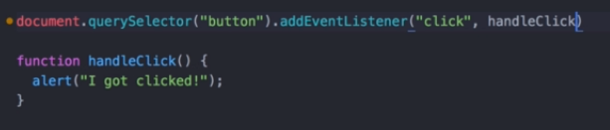

* In the code above an event listener is added on the object button that calls the function handleClick whenever the event i.e. click happens.
* Anonymous functions are functions that don’t have any name. An example of an anonymous function passed as an event listener is given below.

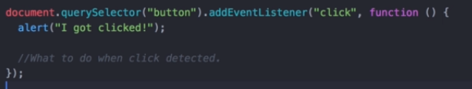

**Lecture 04 (Higher Order Functions and passing functions as arguments)**

* You can pass functions as parameters and then use them in other functions like this.

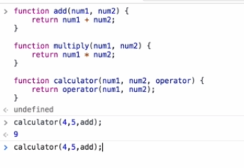

* The functions that can take other functions as inputs are called higher order functions.
* In this case calculator is a higher order functions, this feature is not available in all programming languages.

**Lecture 06 (How to play sounds on a website)**

* You can play audio by creating an audio object and then playing it using the play() method.
* Take a look at the code snippet below.

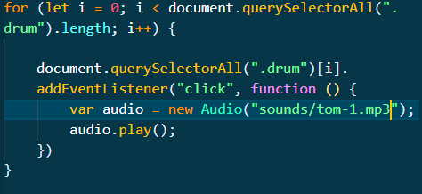

**Lecture 07 (A deeper understanding of Javascript objects)**

* You can simply create objects in javascript using this simple notation:

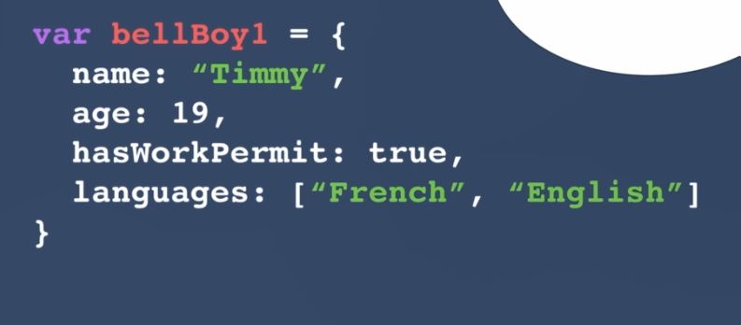

* A function that creates objects is called constructor function.
* It is standard practice to keep the first letter of the name of function capital when making a construction function.
* Following is the example of the code of a constructor function.

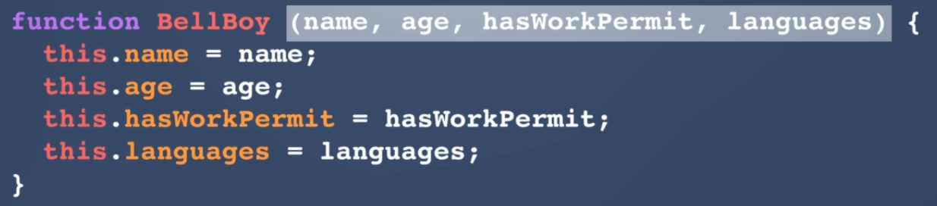

* Inside the constructor function you always match the input to the property name.
* This is how you create an object using the constructor function.

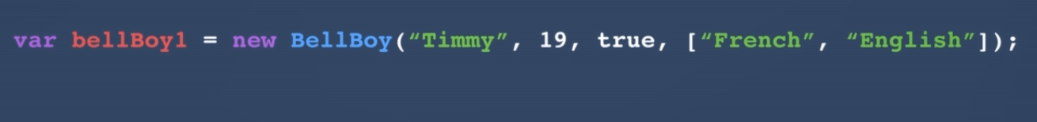

* Only difference in calling a constructor function and a normal function is that in this case we use the new keyword and the name of the function is capitalized wrt to the first letter.

**Lecture 08**

**Lecture 09 (Objects and their methods)**

* You can add methods in your objects by using the following notation:

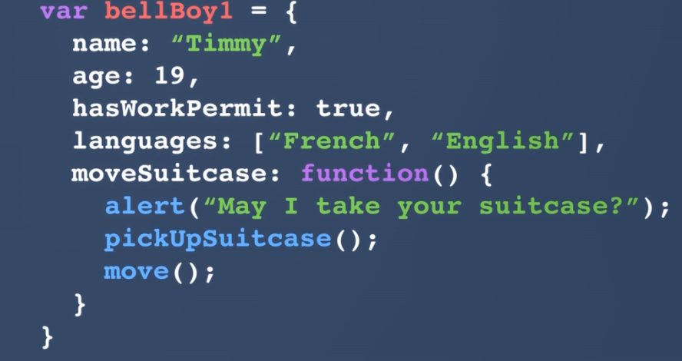

* Here moveSuitcase is the name of the method and when you want to call the object you’d do so by bellboy.moveSuitcase();
* For adding a function in the constructor function you can do this

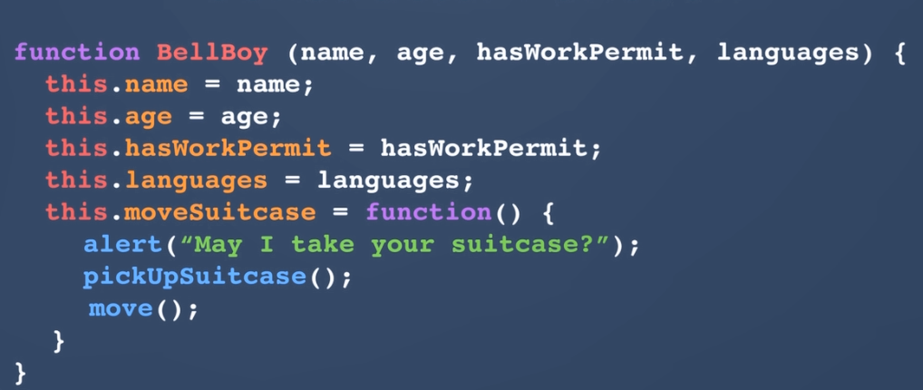

**Lecture 11**

**Lecture 12**

* The function that gets passed in as a parameter inside a function is called Callback function in javascript.

**Lecture 13**